**Outdoor Advertising Control Program Services - RFP**

**DOT22-OAC-01**

**Addendum #1**

**Responses to Vendor’s Questions**

**December 22, 2021**

1. What is the difference for inventory of junkyards between?

1.2.1 Provide a complete statewide sign and junkyard inventory (existing, proposed, removed, and illegal new) when directed by IDOT.

  And

1.2.2 Provide a complete statewide junkyard inventory when directed by IDOT.

**Response:** 1.2.2 is redundant with 1.2.1, there are no differences between the two referenced sections.

1. What is the expected deliverable for the inventory a sign or junkyard that does not exist, i.e. removed?

**Response:** An inspection record with photos of signs prior location to document the sign is no longer in existence.

1. What is the expected deliverable for the inventory of proposed signs and junkyards?

**Response:** An inspection record with photo of proposed site showing the current status of the property and showing that the sign/ junkyard has not yet been erected or built.

1. How are “illegal new” signs and junkyards defined?

**Response:** This was a typo.  It should state “illegal/new”.

1. Are illegal “old” signs and junkyards not to be inventoried?

**Response:** All illegal signs and junkyards are to be inventoried. See answer to question #4.

1. Section 2.1.2 under Pricing on page 24 states “ The total cost per hour stated for each individual shall a fully-loaded hourly rate **inclusive** of salary, benefits, insurance, overhead, travel expenses, equipment expense, and other associated expenses not listed under Section 2.3.”

  Section 2.3 on page 26 states “**EXPENSES ALLOWED:** Expenses [Box] are not allowed [Box checked] are allowed as follows:

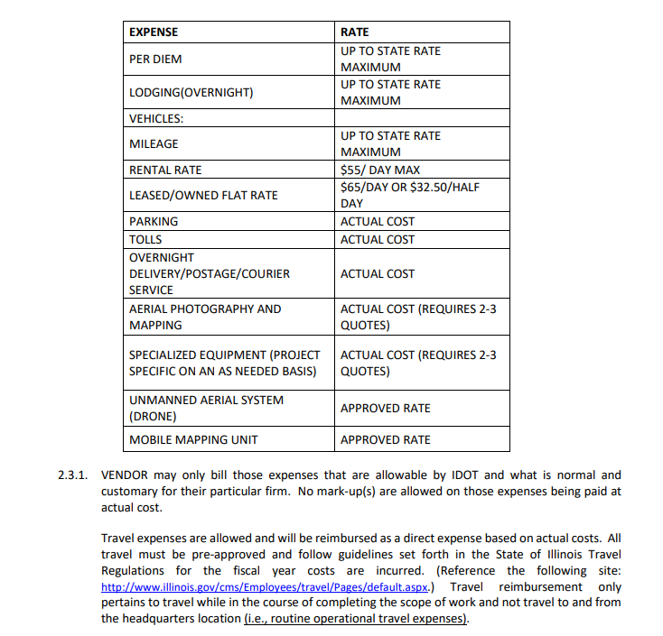

There appears to be a conflict between Sections 2.1.2 and 2.3.1.  If travel expenses are to be included in the fully-loaded hourly rate, why are they listed as a reimbursable direct expense?

**Response:** Any in-state travel expense necessary to complete the required tasks can be billed per the chart in section 2.3.  Any other travel, such as staff traveling from out of state is considered overhead and to be included in the loaded hourly rate.

Also, it is not clear from reading both sections how equipment expenses are to be reimbursed.

**Response:** Any equipment listed in the chart in section 2.3 may be billed per the chart, any other equipment not listed is considered overhead and should be included in the loaded hourly rate.

7. Attachment NN, Section 2.11.2.2 on page 71 requires the entry of relevant NAICS codes for each DBE subcontractor.  Which NAICS codes are relevant to this contract?

**Response:** Section 7.11.2.2 is revised to state “A detailed description of the commercially useful work to be done by this DBE as follows”:

Relevant NAICS codes is removed from this section.

  8. Are anticipated direct expenses to be included on Attachment NN, Section 7.11.2.3 on page 71?

**Response:** leave this section blank.

9. Are the 4,500 hours in the odd number years under Support Staff intended to provide the necessary resources for both inventories?  If not, when will junkyard inventories be required?

**Response:**  Yes. The additional hours for Support Staff, Project Manager, and Project Engineer are to account for the additional work needed for both the sign and junkyard inventories.