State of Illinois
Department of Transportation
Bureau of Business Services
Specifications and Questionnaire for a 24’ Tandem Axle, Van Body (enclosed) Trailer
July 2019
This specification and questionnaire covers a 24’ Tandem Axle, Van Body (enclosed) Trailer for use in the Department of Transportation Operations. In an effort to improve operating efficiency, parts and service availability the Department of Transportation is specifying acceptable units by required equipment and accessories as outlined below.
Each bidder shall submit with their bid two sets of descriptive literature and specifications describing all the equipment and options proposed. This information shall be clearly marked to indicate the make, model, and accessories proposed to be furnished.
Bidders quoting on other-than-specified equipment must submit with their bid written proof of the following:
- The equipment proposed equals or exceeds that specified in all respects including capacity, operating features, and accessory items.
- The manufacturer of the equipment proposed has been actively involved in the manufacture of the equipment called for in the specifications for a period of not less than 5 years.
- Parts and service for the equipment proposed are readily available within the State of Illinois.
It is the responsibility of each bidder to complete and return this questionnaire with the bid.

Unless otherwise specified, the proposed equipment shall be complete in all parts and ready for immediate use upon delivery.
Bidders are advised to carefully read these specifications as changes have been made since the last solicitation issue.
Proposed with This Bid:
Make:
Model:
Manufactured by:
Bidder:
Contact name:
Telephone:
Email:

The Illinois Department of Transportation reserves the right to waive minor informalities, deficiencies or technical variances which by their nature are restrictive to a given manufacturer, if in its’ judgement, it would be in the best interest of the State to do so and it would not prejudice the rights of other bidders.
Serviceability will be a factor in award. Successful bidder shall either be able to provide service after purchase or shall indicate other qualified service facilities able to service equipment, within a reasonable period of time at agency locations. Bidder shall provide documentation and enumerating service locations. A Review of the bidder's ability to provide prompt parts and service to the State of Illinois and in particular to the delivery location, will be considered in determining award.
Bids will only be accepted from established manufacturers or their authorized dealers. Any dealer submitting a bid hereby guarantees that it is an authorized dealer of the manufacturer and that the manufacturer has agreed to supply the dealer with all quantities of products required by the dealer in fulfillment of its obligations under any resultant contract with the State. Bidder must submit authorized dealer letter upon request.
Warranty:
Manufacturers’ standard warranty shall be provided. Bidder shall attach copies of warranty with bid. Warranty shall commence at the Illinois Department of Transportation in-service date. If any equipment fails to conform to the warranties during the applicable warranty period, the Vendor or Manufacturer will adjust, repair or replace the equipment at no charge to the Department as soon as possible upon notice from the Department. Equipment shall be repaired on-site and will be performed at no additional cost to the Department.
The Vendor may provide or perform warranty service at a dealer location within the Districts geographic region if on-site repair is not possible. Vendor shall facilitate pickup and delivery of equipment at Vendor's cost if warranty repair(s) are made off-site during the warranty period. The contract Vendor is responsible for any failure of their allied or subcontractors’ fulfillment of said warranties. Failure to provide this service shall result in a “Complaint to Vendor” that could affect future bid awards.
Delivery:
It will be the responsibility of the successful vendor to guarantee delivery within the quoted time and to require allied manufacturers or suppliers to complete the installation of auxiliary equipment in accordance with the quoted delivery time.
Failure to comply with the quoted delivery time because of delays resulting from the inability of suppliers of allied equipment such as bodies, snowplows, spreaders, etc., may be reason to refuse to consider similar items from those suppliers on future bids.
All equipment provided by the Vendor and the sub-contractor(s) shall be fully operational when delivery is made. Any noted defects at the time of delivery shall be addressed by Vendor in the first 30 days of in-service.
Bidder/Vendor acknowledges the requirements above. Yes No
Bidder/Vendor Initials: |  | Date:
Note: If the equipment proposed exceeds the minimums called for in the specification please do not mark NO. Mark YES and explain with a short comment on how it exceeds.

Trailer:
The 8’5” x 24’ trailer shall comply with all current Federal and State Safety Standards.
Complies: Yes No
Van body style (enclosed) trailer with tandem axles and four (4) pneumatic tires on the ground.
Number of tires:
Inside width of trailer 94-96”:
Inside Width:
The interior trailer length 24’-0
Length:
The trailer shall be constructed with a flat or dome roof to an approximate inside height of 7’.
Inside height:
Roof and sidewall construction shall be constructed to support an aluminum roof rack system.
Complies: Yes No
Main frame construction consisting of tubular or I-beam design.
Describe frame:
Trailer undercarriage shall be coated with automotive type protective spray coating.
Complies: Yes No
V-nose design is acceptable if overall floor dimensions are maintained as specified.
Describe design:
Body/Interior:
The trailer shall be constructed with .030” thick orange, silver or blue aluminum skin.
Complies: Yes No
The sidewalls shall be finished on the interior with a minimum 3/8” plywood.
Complies: Yes No
The front exterior of the trailer shall be equipped with an aluminum front cap or extended stone guard and protective corners.
Complies: Yes No
The floor shall be doubled 3/4” plywood.
Complies: Yes No
Crossmember and wall stud spacing shall be no greater than 16” center to center for the full length of the trailer.
Crossmember and wall stud spacing: |  | center to center
Inner fenders shall allow for maximum width and consist of steel construction.
Complies: Yes No

The roof shall include a minimum of three (3) translucent roof vents.
Complies: Yes No
Interior roof panels shall be white.
Complies: Yes No
Interior lighting shall consist of three (3) LED lights switched and wired to draw 12volts from tow vehicle.
Complies: Yes No
EZ track anchoring system shall run full length of trailer interior approximately 3’ up from floor deck.
Complies: Yes No
A minimum of six (6) flush mount 5k D-rings spaced evenly in floor.
Complies: Yes No
Roof Rack System:
Roof rack shall be constructed of aluminum uprights, ladder with non-slip steps and perforated anti-skid cat walk able to support an average of 250 lbs.
Describe design:
Complies: Yes No

Picture is for roof rack reference only. Do not scale from picture.
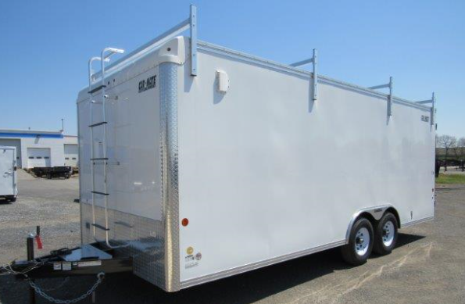

Doors/Openings:
The trailer shall have two side doors, one on each side near the front. They shall be approximately 36” wide, 6’ in height. Hinges shall be heavy-duty design. The doors shall also be equipped with aluminum door props and door lock closure securing both top and bottom of doors. Doors shall be water tested for leaks before delivery.
Door size:
Complies: Yes No
One (1) heavy-duty locking rear ramp door on back of trailer with spring assist in lifting and lowering door with folding extension ramp. Doubled deck or single deck with aluminum tread cover is acceptable. Rear stabilizer jacks shall be included for loading. All hinged ramp doors shall include a metal hinged Transition flap where the interior floor deck and ramp pivot.
Complies: Yes No
Picture is for rear ramp reference only. Do not scale from picture.
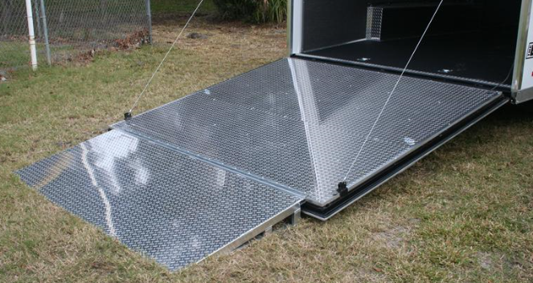
Trailer tongue:
Designed for bumper pull. Triple tube A-frame design, maximum length required to accommodate trucks with attached equipment, adjustable channel height 2-5/16 inch ball coupler with capacity to meet or exceed total GVW of trailer, 3500lb. tongue jack with sand shoe.
Complies: Yes No
Describe design:
Safety chains and hooks rated for trailer GVW shall be included.
Truck Connection for Lighting and Electrical:
Type – 7-way connector, utilizing round pins and sockets, SAE/ATA approved, plug portion installed on trailer lead, pin portion is provided with the truck installation.
Complies: Yes No
Breakaway System:
The electric brake system shall include a sealed breakaway safety system.
Complies: Yes No
Axle / Suspension:
Axle and suspension shall consist of two (2) 7,000lb. axles with spring or torsion flex type suspension. Hubs shall be EZ lube design. Brakes shall be electric self-adjusting type located on both axles.
Complies: Yes No
Component:
Make:
Model:
Tires and Wheels:
Tires and wheels shall be new, first run quality, radial size ST235/80R16 or as needed to meet GVWR with matching spare tire and wheel mounted in the floor or interior side wall as needed. Wheels shall be manufacturers standard color.
Brand Name:
Tread:
Size:
Capacity each:
Wiring and Lights:
All holes in the body shall be grommetted and sealed and junction boxes provided when necessary.
Complies: Yes No
Lighting and reflectors shall comply with the Illinois Motor Vehicle Laws and Federal safety requirements.
Complies: Yes No
All exterior lights shall be LED and mounted in shock-proof light mountings.
Complies: Yes No
Two (2) switched, alternating Amber/Clear LED warning strobes shall be mounted in the rear above tail lights.
Complies: Yes No
DOT approved reflective conspicuity tape shall run entire length of trailer at bottom of side walls and rear gate.
Complies: Yes No
General:
One copy of the owner manual shall be included at delivery.
Complies: Yes No
Instruction by qualified factory or dealer personnel covering operation and maintenance of the trailer shall be provided at time of delivery.
Complies: Yes No
Full coverage warranty for a minimum 12 months shall be provided. Bidder shall attach copy of warranty with bid.
Describe warranty:
Delivery:
This equipment is to be delivered in first-class operating condition with acceptance subject to Department of Transportation inspection and approval.
Complies: Yes No
The trailer shall be delivered greased, serviced and ready for operation.
Complies: Yes No
Bid Package:
If not quoting in BidBuy, bidders will need to send two copies of each of the following with their bid response.
a) Specification Questionnaire
b) Descriptive Literature

